**Crop Disease Prediction**

**PROJECT SYNOPSIS**

OF MINOR PROJECT

5th Semester

# BACHELOR OF TECHNOLOGY

COMPUTER SCIENCE AND ENGINEERING (AI &AI ML)

## SUBMITTED BY

**Anurag Yadav** - 301310922041

**Anmol Kumar** - 301310922020

**Supriya Dhara**- 301310922009

**S. Nimmi**- 301310922114

## Session 2024-2025



**RUNGTA COLLEGE OF ENGINEERING AND TECHNOLOGY BHILAI(C.G)**

## Rungta College of Engineering and Technology, Bhilai Department of CSE -AI/AIML

**Table of Contents**

|  |
| --- |
| **S.No. Title Page No.** |
|  |
| 1. 1. Introduction 01 |
|  |
| 1. 2. Rationale Behind the Study 02 |
|  |
| 1. 3. Objective 03 |
|  |
| 1. 4. Literature Review 04 |
|  |
| 1. 5. Feasibility Study 05 |
|  |
| 1. 6. Methodology/ Planning of work 06 |
|  |
| 1. 7. Flow Chart 07 |
|  |
| 1. 8. Expected Outcomes 08 |
| 9. References 09 |

**Guide Name**

**Prof. Prabhjeet Kaur**

**CSE(AI/AIML)**

**Consent of Guide**

**Suggestions by the guide:**

**B. Tech Project Synopsis**

**Introduction:**

The agricultural sector is increasingly challenged by crop diseases that pose a serious threat to food security and farmer livelihoods. These diseases can lead to significant yield losses, resulting in economic hardship for farmers and jeopardizing the stability of agricultural markets. Traditional methods of disease detection, which often rely on visual inspections and expert knowledge, are inherently limited; they can be time-consuming, subjective, and prone to error.

Recent advancements in deep learning technologies offer a transformative approach to crop disease prediction, enabling more efficient and accurate systems for early detection. By utilizing sophisticated algorithms and vast datasets, deep learning can analyse visual data and identify disease symptoms that may be missed by the human eye. This not only enhances the speed of diagnosis but also improves the overall reliability of disease management strategies.

In recent years, advancements in machine learning and computer vision have opened new avenues for crop disease detection. Convolutional Neural Networks (CNNs), a deep learning model particularly well-suited for image recognition tasks, have emerged as a powerful tool for identifying diseases based on images of plant leaves. CNNs can automatically learn to recognize patterns in images, making them highly effective for distinguishing between healthy plants and plants affected by various diseases.

**Rationale Behind the Study:**

The increasing frequency and severity of crop diseases pose a significant threat to global food security, farmer livelihoods, and the agricultural economy. As the world population continues to grow, the demand for food is rising, necessitating improvements in agricultural productivity and sustainability. Traditional methods of disease detection often fall short due to their reliance on manual inspections, which can be time-consuming, subjective, and prone to error. This situation calls for innovative solutions that leverage technology to enhance the efficiency and accuracy of crop disease management.

**Key Reasons for Conducting the Study:**

**Need for Early Detection**: Early identification of crop diseases is essential for effective management. The cost of inaction can be dire, resulting in not only decreased yields but also increased financial burdens on farmers. By implementing an AI-driven system for timely interventions, the potential for improving crop health and overall productivity becomes significantly higher.

**Advancements in Deep Learning**: The rapid advancements in deep learning technologies present an exciting opportunity for accurately detecting and diagnosing plant diseases through image analysis. With the ability to process vast amounts of visual data, deep learning algorithms can identify disease symptoms more effectively than traditional methods, promising higher accuracy and faster diagnoses.

**Integration of Environmental Factors**: Crop diseases are influenced by a variety of environmental conditions, including weather patterns, soil health, and moisture levels. This study aims to explore the synergetic potential of combining image data with real-time environmental inputs, enhancing predictive capabilities and offering a more holistic approach to disease management.

**Objectives:**

**1. Disease Area Identification and Localization**

To develop a method for accurately identifying and localizing the affected area of the leaf to enhance disease severity estimation and provide more detailed diagnostics.

**2.Accurate Multi-Disease Detection**

Develop a robust system to detect and classify multiple crop diseases simultaneously, ensuring high precision and reliability.

**Literature Review**

|  |  |  |  |  |  |  |  |
| --- | --- | --- | --- | --- | --- | --- | --- |
| S.No. | Author’s  Name | Title | Source | Y  e  a  r | Methodology | Findings | Gaps |
| 1.  2. | Md. M. Islam et al.  Kaur, M., & Bhandari, S. | Deep Crop: Deep learning-based crop disease prediction with web application  Web-Based Application for Plant Disease Detection using CNN | Journal of Agriculture and Food Research  International Journal of Computer Applications | 2  0  2  3  2  0  2  2 | Uses CNN on PlantVillage images to create a web app that enables farmers to detect and classify plant diseases from leaf photos.  Created a CNN model integrated into a web application allowing farmers to upload images for diagnosis. | CNN for plant disease detection, making it ideal for a web application to aid farmers in diagnosing crop diseases efficiently.  Developed a user-friendly web application for real-time disease detection. | Developing a localization method to identify the area of disease in the leaf, multiple disease detection.  Lacks integration of environmental data and feedback mechanisms. |
| 3. | Kouadio, A. A., et al. | Image Classification for Plant Disease Detection using Deep Learning | IEEE Access | 2  0  2  1 | Compared multiple CNN models using the PlantVillage dataset to evaluate their accuracies and efficiencies. | Established benchmarks for various CNN architectures in crop disease classification. | Insufficient exploration of hybrid models incorporating environmental data. |

**Feasibility Study:**

**Technical Feasibility:**

* **Data collection**:

The system will need access to high-quality datasets of crop images, along with environmental data such as temperature, humidity, and soil conditions. Partnerships with agricultural research organizations may be necessary to obtain diverse and comprehensive datasets.

**Economic Feasibility:**

* **Cost Analysis:**

Estimate the initial and ongoing costs associated with implementing the

project, including data acquisition, equipment, software, personnel, maintenance and operational expenses.

**Environment Feasibility:**

* **Impact Assessment:**

The system aims to enhance sustainable agricultural practices by reducing the need for chemical pesticides through early disease detection, leading to environmentally friendly farming.

**Methodology/ Planning of work:**

**Data Collection Module**

**Sensors:** Collect data on environmental conditions such as temperature, humidity, soil moisture, and light levels.

**Remote Sensing:** Uses drones, satellites, or aerial imagery to capture visual data of crop fields.

**Field Surveys:** Manual or semi-automated collection of data from field observations and sample testing.

**Data Integration and Storage Module**

**Data Aggregation:** Combines data from various sources, including sensors, remote sensing, historical records, and weather forecasts.

**Data Storage:** Manages and stores collected data in a structured format, typically in a cloud-based or local database**.**

**Preprocessing Module**

**Data Cleaning:** Removes noise and irrelevant information from raw data to improve quality.

**Normalization:** Standardizes data formats and scales for consistency.

**Feature Extraction:** Identifies and extracts relevant features from the data that are useful for analysis.

**Disease Detection Module**

**Image Analysis:** Uses computer vision techniques and machine learning algorithms to analyze images of crops for signs of disease.

**Pattern Recognition**: Identifies disease patterns and anomalies based on visual and sensor data.

**Anomaly Detection:** Detects deviations from normal patterns that may indicate the presence of diseases.

**FLOWCHART**

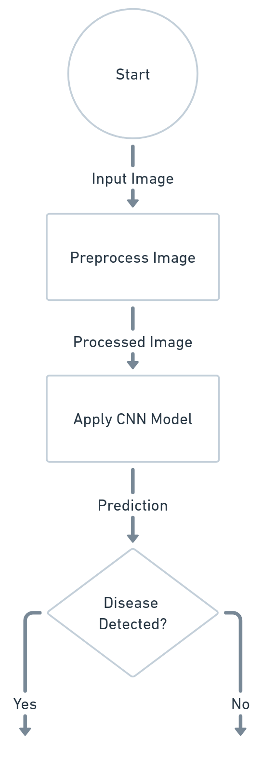

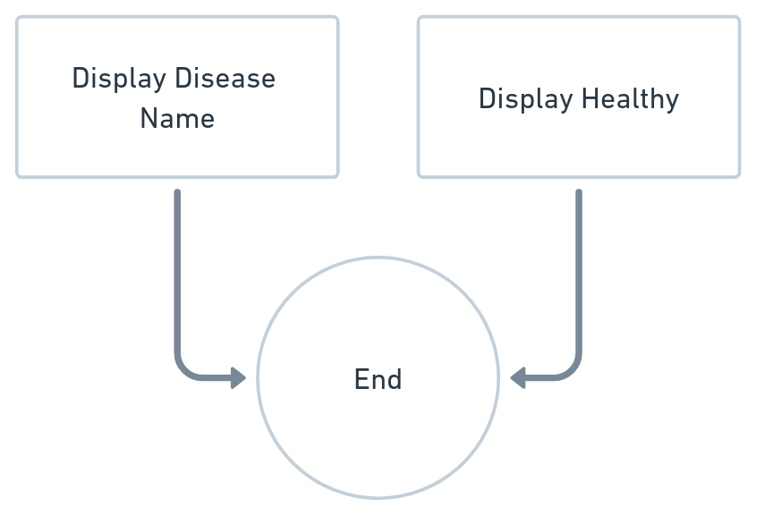

**Expected outcomes:**

**1. Accurate Localization and Severity Assessment of Leaf Disease Areas**

Enhanced capability to accurately pinpoint and quantify the affected regions on the leaf, allowing for more precise disease severity assessment and localized treatment recommendations.

**2**.**Impact of Accurate Multi-disease detection**

The system will accurately detect and classify multiple crop diseases simultaneously with high precision and reliability. It will enable early intervention, improve crop health monitoring, and enhance agricultural productivity. Additionally, it will support sustainable farming by reducing pesticide overuse through targeted treatments.

**References**

* Islam, Md Manowarul, et al. "Deep Crop: Deep learning-based crop disease prediction with web application." *Journal of Agriculture and Food Research* 14 (2023): 100764. <https://www.sciencedirect.com/science/article/pii/S2666154323002715>